Assignment 1a

STEPS:

1. Setting thresholds:

*k = 4*

*Tmin = 200*

*Tmax = 240*

This was the best *k* to clearly see the performed motion estimation as demonstrated below:

k = 1:

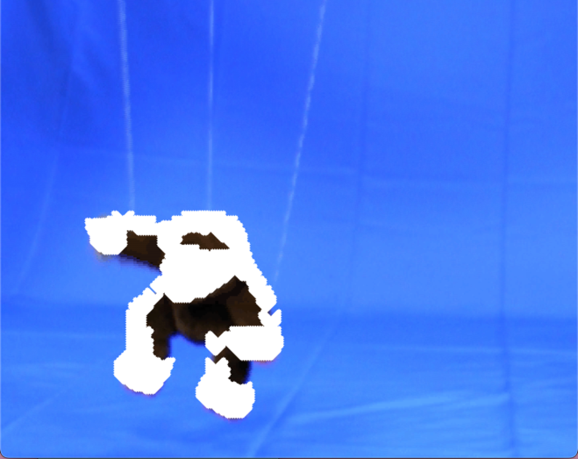

k = 2:

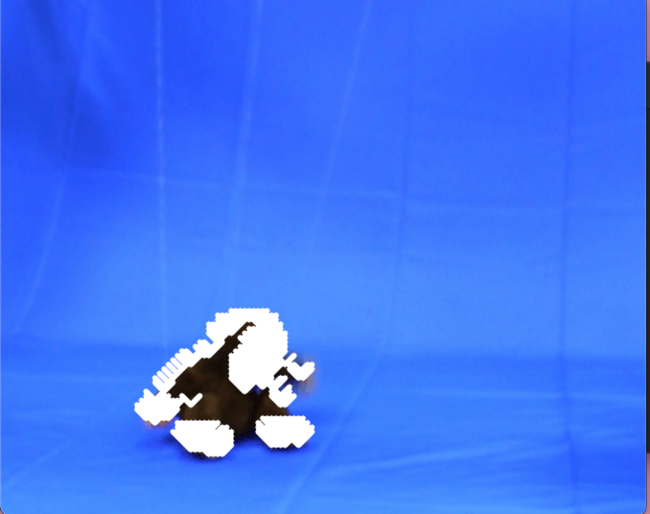

k = 3:

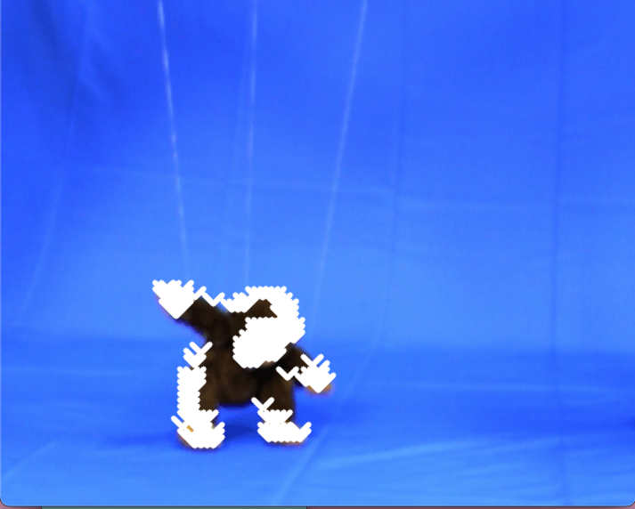

k < 4 results in arrows that are too dense.

k = 5:

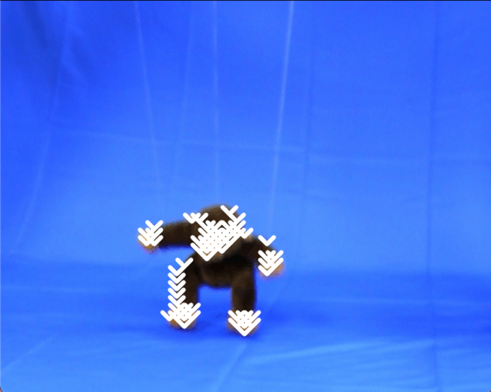

k = 6:

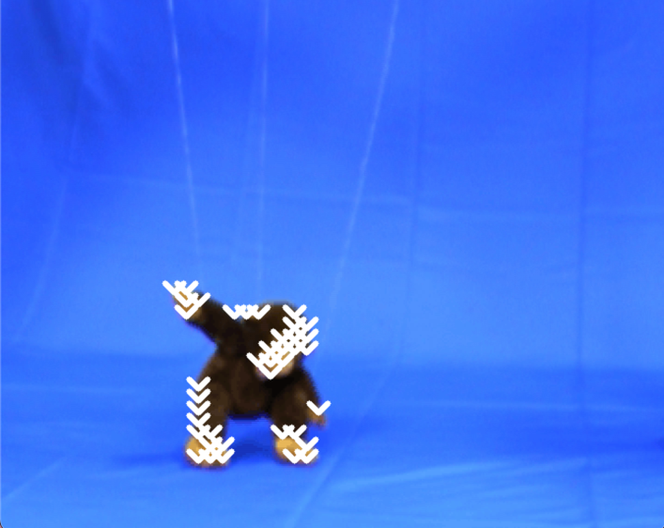

k > 4 results in arrows that are too sparse.

Tmin and Tmax are the thresholds for noise filtering. From the printed list of sums from the SSD calculator, I was able to determine these values.

1. Run rest of code:
   1. Import libraries
   2. Second section:
      1. Load video (“monkey.avi”)
      2. Get frame dimensions
      3. Create an output to video writer
      4. Define parameters
      5. Load all frames and append them to frames array
   3. SSD calculator
   4. Helper function to draw arrows - arrowdraw
   5. Convert image to RGB since OpenCV uses BGR image format
   6. Main code for performing motion estimation:
      1. Capture first frame from monkey.avi to use as background
      2. Iterate through all of the frames
      3. Create a mask to isolate monkey from blue background (i.e. anything that isn’t blue and is dark/light brown gets isolated)
      4. Create an array to store displacement vectors
      5. Iterate through grid blocks of size 2k+1 \* 2k+1 in the monkey frame
      6. Visualize displacement vectors as arrows on monkey frame
      7. Save frames to output videos